Instructions for Posting Solution on GDB

- Open your math type software
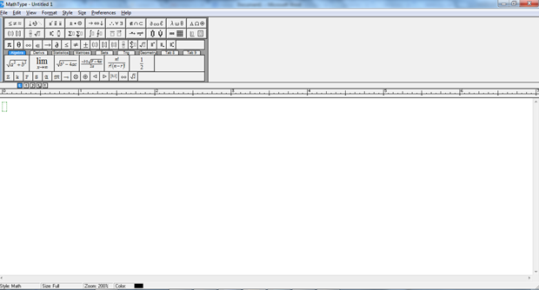
- Click on the Preference tab
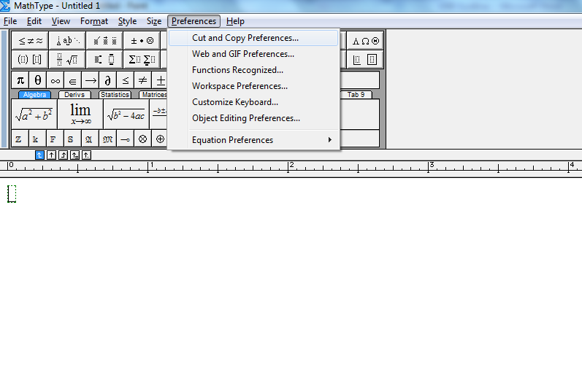3. Then click on Cut and Copy Preference
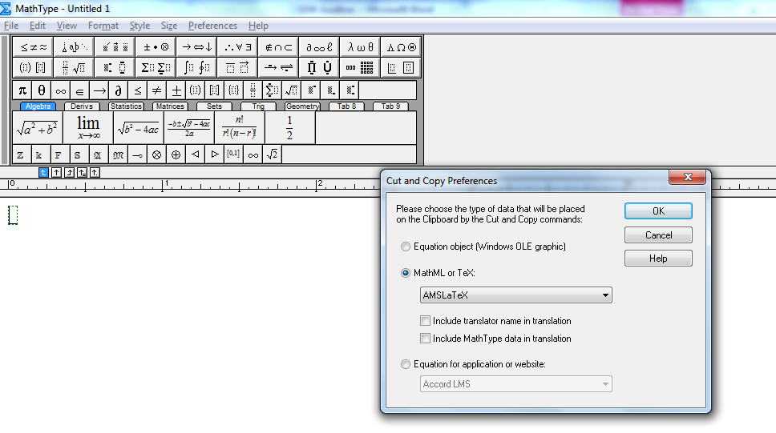
Select “MathML or Tex” and then from the drop down select AMSLatex
Uncheck every other option.
- Write your solution on Math Type
For example:
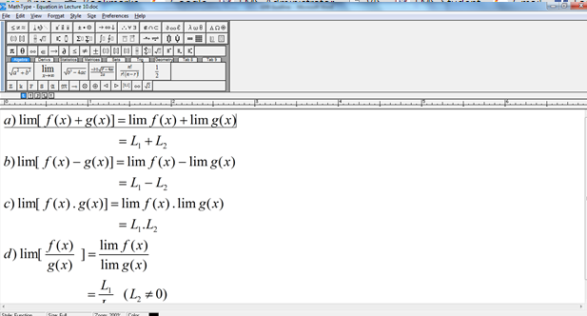

- Select all equation by CTRL + A and the copy by CTRL + C
- Then open the website
http://www.numberempire.com/texequationeditor/equationeditor.php
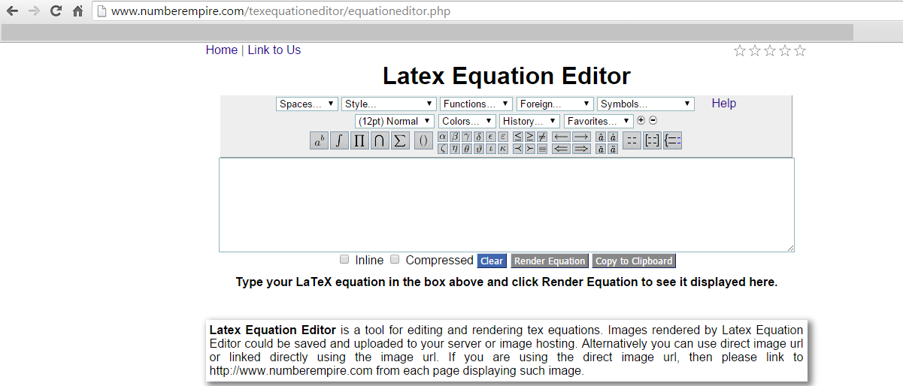

- Now paste the solution in the yellow text box by pressing CTRL +V

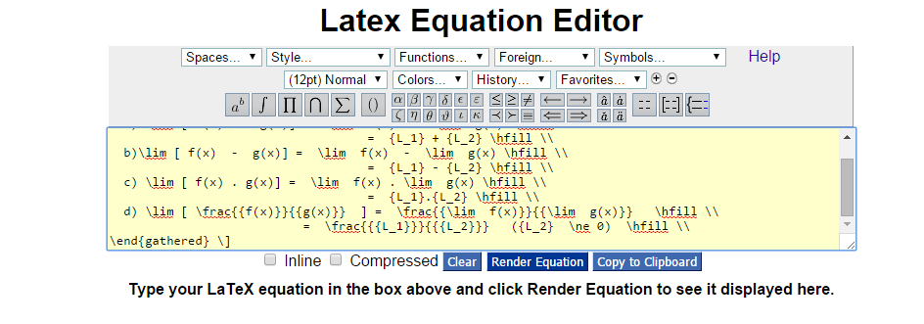
- Check the box “inline” which is under the yellow text box
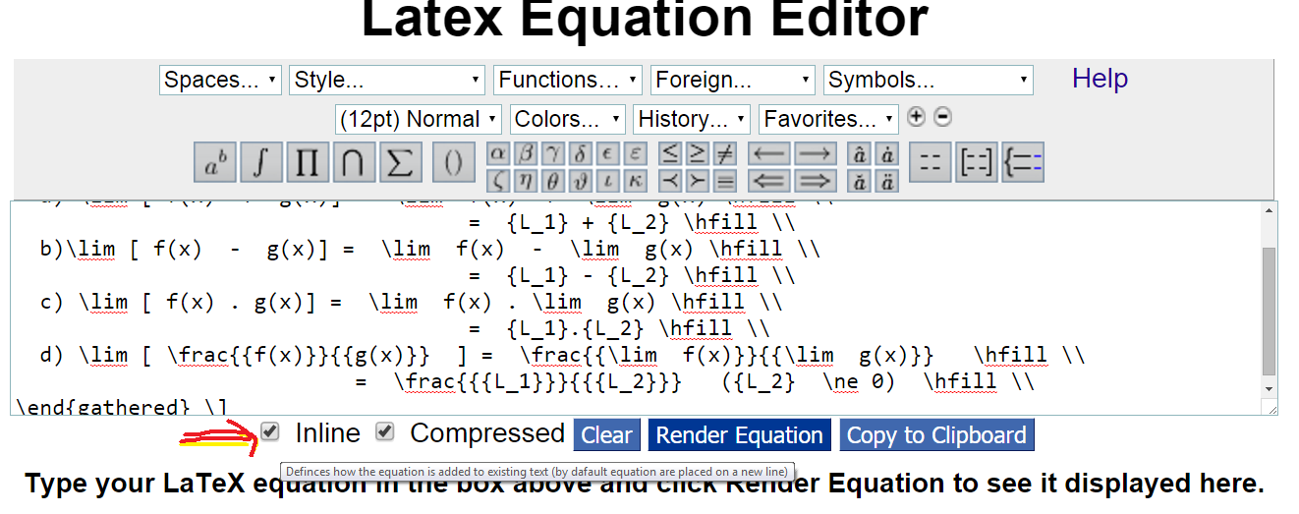
- Now click “Render Equation” Button

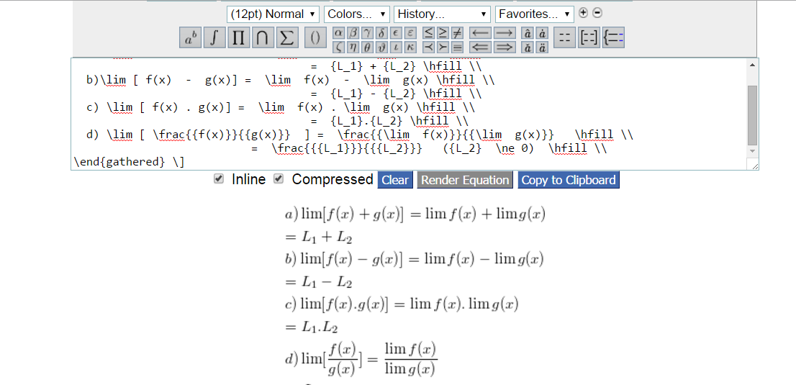

Your solution will be visible to you. Right click on the solution and select copy image.

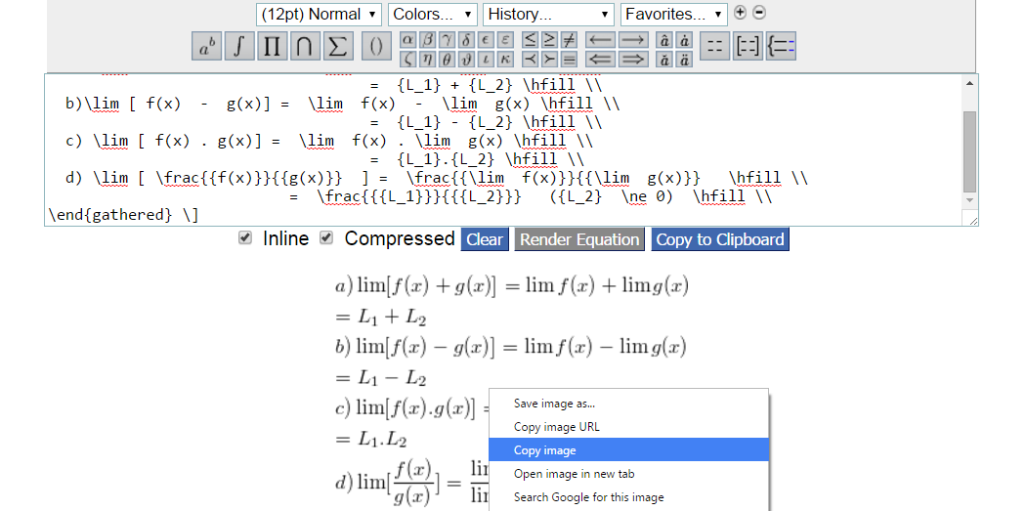

- Now paste your solution at GDB window
- 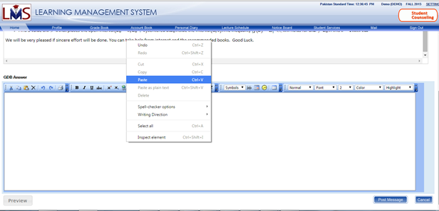

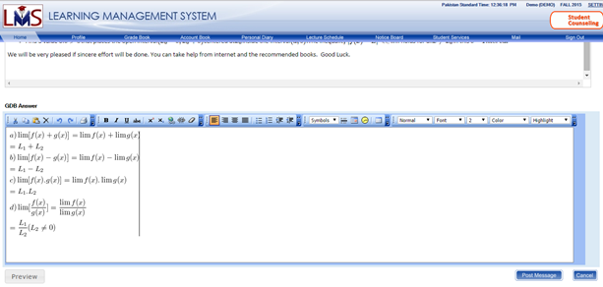

It will display correctly. You can also check by pressing the Preview button and then click on post message button.

